15.01.2010
CME 2003 LOGIC DESIGN
FINAL EXAM

(20) | 1 | - Using JK flip flops design a counter to produce following sequence: 5 6 3 2 1. (Give only the expressions for the J and K inputs. No need to draw the circuit.)  - Determine the behavior of the circuit in the case of entering unused states.
(10) | 2 | Implement the F function using a 3:8 decoder with a OR gate. If it is possible to do using a 2:4 decoder, show them.
(25) | 3 | - Analyze the clocked synchronous state machine below and then draw a state diagram for this state machine (x: input, z:output).  - Is this machine a Mealy machine or a Moore machine? Explain?  - Fill in the transition/output table for the above state machine.  - Draw the Flow Chart for this ASM.  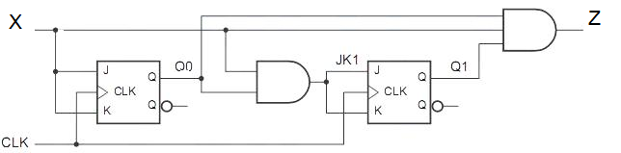
  Present States | Next States |  | Output
  Present States | X = 0 | X = 1 | X = 0 | X = 1
  Q₁ Q₀ | Q₁⁺ Q₀⁺ | Q₁⁺ Q₀⁺ | Z | Z
  0 0
  0 1
  1 0
  1 1
(15) | 4 | Implement the F function using 3 selection multiplexers. Is it possible to do with 2 selection multiplexers?  Z=F(A,B,C,D)= ∑(2, 4, 9, 10, 12, 13) with don’t care conditions = (1,5,8,11)
(10) | 5 | What are the differences between an asynchronous counter and a synchronous counter? Which of them is better? Why?
(10) | 6 | A 4-bit ripple up counter consists of flip-flop that each has a propagation delay from clock to Q output of 16ns. For the counter to recycle from 1110 to 0001, it takes a total of …... ns
(10) | 7 | How many bits can you store in an RAM which has 4K address locations with 16 data lines? What is the numbers of the address lines?
 |  | Transition Table for JK Flip Flop
 |  | OUTPUT TRANSITION |  | FLIP-FLOP INPUTS
 |  | Q_{n} | Q_{n+1} | J | K
 |  | 0 | 0 | 0 | X
 |  | 0 | 1 | 1 | X
 |  | 1 | 0 | X | 1
 |  | 1 | 1 | X | 0

